# Name: Session:

**Programming II**

**Lab Exercise 3.13.2020 Stardate: 73196.72**

# Breakout Project

You will create the following Form. Your form will contain 20 blocks which are PictureBoxes. It will also contain two PictureBoxes (Ball and Paddle) as well as a Timer control and two labels to display Lives and Score.

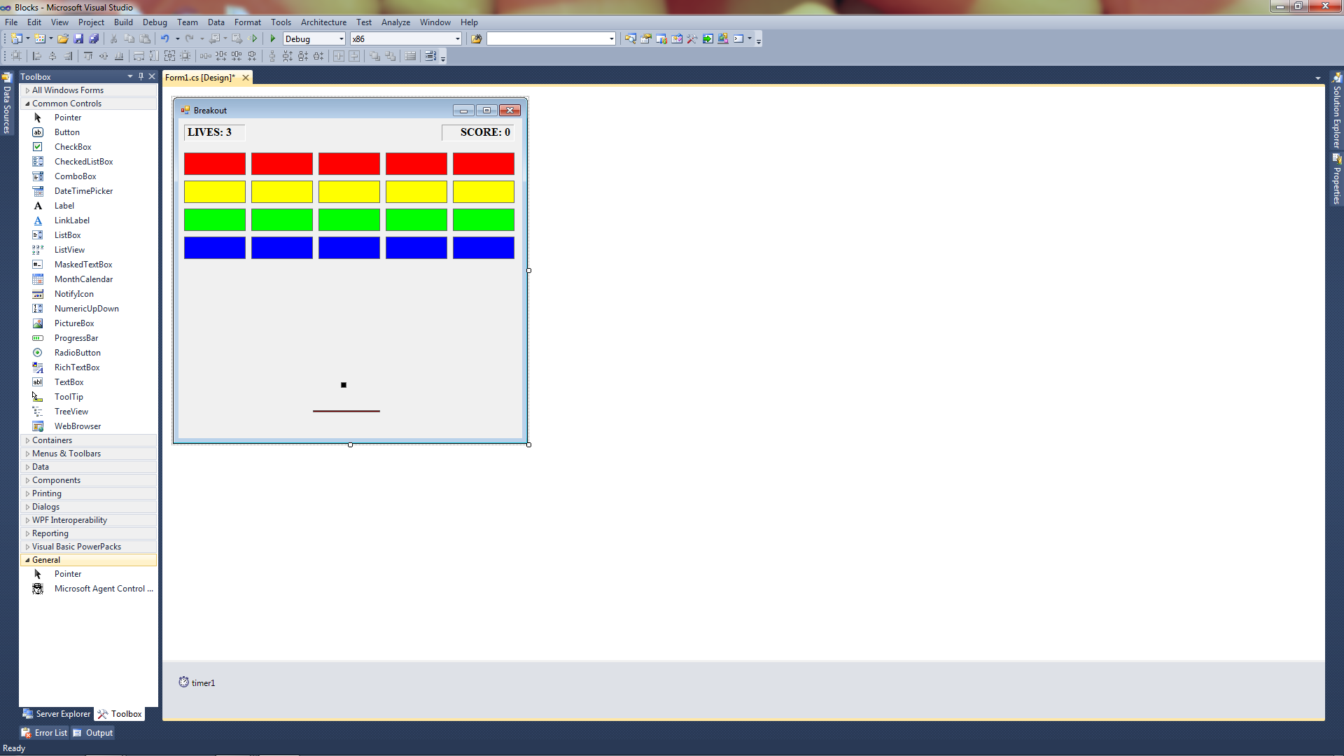

1. Declare the following variables global to your Form.

int intSpeedX = 2;

int intSpeedY = -2;

int intScore;

int intLives = 3;

int intAllGone;

1. Add the following code to your Form1_Load subprogram.

timer1.Enabled = true;

1. Add the following code to the timer1_Tick event.

AllGone = 0;

CheckCollisions();

if (AllGone == 1)

{

timer1.Enabled = false;

MessageBox.Show("Congratulations, you finished the game");

}

BallX += SpeedX;

if (BallX < 3 || BallX + Ball.Width > this.Width)

SpeedX = -SpeedX;

BallY += SpeedY;

if (BallY < 3)

SpeedY = -SpeedY;

if (BallY + Ball.Height > this.Height - 5)

{

timer1.Enabled = false;

UpdateLives();

BallX = 232;

BallY = 376;

SpeedX = 2;

SpeedY = -2;

if (Lives < 1)

{

MessageBox.Show("You have lost the game. OH NO!");

}

else

{

MessageBox.Show("You missed. OH NO!");

timer1.Enabled = true;

}

}

1. Add the following code to the Form1_MouseMove event

Paddle.Left = e.X - Paddle.Width / 2;

1. Add the following functions to your Form code. Note the Overloaded version of CheckCollision. If you do not know what overloading is, look it up.

public void CheckCollisions()

{

CheckCollision(Paddle, false);

CheckCollision(Red1);

CheckCollision(Red2);

CheckCollision(Red3);

CheckCollision(Red4);

CheckCollision(Red5);

CheckCollision(Yellow1);

CheckCollision(Yellow2);

CheckCollision(Yellow3);

CheckCollision(Yellow4);

CheckCollision(Yellow5);

CheckCollision(Green1);

CheckCollision(Green2);

CheckCollision(Green3);

CheckCollision(Green4);

CheckCollision(Green5);

CheckCollision(Blue1);

CheckCollision(Blue2);

CheckCollision(Blue3);

CheckCollision(Blue4);

CheckCollision(Blue5);

}

public void CheckCollision(PictureBox src , Boolean Hide)

{

if (src.Visible == true)

{

if (BallX > src.Location.X && BallX < src.Location.X + src.Size.Width && Ball.Location.Y > src.Location.Y && Ball.Location.Y < src.Location.Y + src.Size.Height)

{

SpeedY = -SpeedY;

UpdateScore();

if (Hide)

src.Visible = false;

}

AllGone += 1;

}

}

public void CheckCollision(PictureBox src)

{

//call the original version

CheckCollision(src, true);

}

public void UpdateScore()

{

Score += 10;

Label2.Text = "SCORE: " + Score;

}

public void UpdateLives()

{

Lives -= 1;

Label1.Text = "LIVES: " + Lives;

}

1. Add the following Properties to your Form code.

public int BallX

{

get

{

return Ball.Left;

}

set

{

Ball.Left = value;

}

}

public int BallY

{

get

{

return Ball.Top;

}

set

{

Ball.Top = value;

}

}

public int Lives

{

get

{

return intLives;

}

set

{

intLives = value;

}

}

public int SpeedX

{

get

{

return intSpeedX;

}

set

{

intSpeedX = value;

}

}

public int SpeedY

{

get

{

return intSpeedY;

}

set

{

intSpeedY = value;

}

}

public int Score

{

get

{

return intScore;

}

set

{

intScore = value;

}

}

public int AllGone

{

get

{

return intAllGone;

}

set

{

intAllGone = value;

}

}

**When you have your program working, print a screenshot of your running program, attach to this sheet and turn in.**